SAS Assignment 3
MI 353
Group 4
Donald Bookman, Christopher Gray, Ryan Johnson and Alexander Rodriguez

Examine the distribution of the target variable. What is the proportion of individuals who purchased organic products?
The target variable in this dataset is called TargetBuy and it is a binary variable that tracks whether or not an individual purchases organic products. A label of 1 means that the individual does purchase organic products, and a label of 0 means that the individual does not purchase organic products. There are 10,000 total individuals in the dataset and 2,434 of them purchase organic products, making the proportion of individuals who purchase organic products 24.34%.
As noted above, only TargetBuy will be used for this analysis and should have a role of Target. Can TargetAmt be used as an input for a model used to predict TargetBuy? Why or why not?
The TargetAmt variable shows the number of organic products a consumer purchases. This variable will not be useful as an input variable for our model because there would be a direct perfectly linear correlation with TargetAmt. This variable is a record of their organic purchases, so it would not be useful in predicting whether or not they actually purchase organic products because this variable already tells you whether or not they do.
Decision Tree 1
How many leaves are in the optimal tree?
In the first decision tree model, we used average square error as the model assessment statistic. This gave us 29 leaves in our optimal decision tree.
Which variable was used for the first split?
The first split is based off of the root node for our model. The variable used for the first split was age and the two classifications were under 44.5 or 44.5 or older or missing values.
What were the competing splits for this first split?
The competing splits for the first split were Affluence Grade and Gender, with variable importance values of 0.8477 and 0.5310, respectively. These splits had less variable importance than our root node, Age, which had a variable importance of 1.
Decision Tree 2
How many leaves are in the optimal tree?
In the second decision tree model, we used average square error as the model assessment statistic, but this time we increased the maximum branches to 3. This gave us 33 leaves in our optimal decision tree.
Based on average square error, which of the decision tree models appears to be better?
When comparing the average square error of the first and second decision tree model, we found the errors weren’t off by much. The first decision tree model had a training average square error of 0.132861 and validation average square error of 0.132773. The second decision tree model ran had a training average square error of 0.133009 and a validation average square error of 0.132662. Due to these results, we can conclude that decision tree one is a slightly better model because the average square error is lower than decision tree two which means that our first model is more efficient.

Appendix: Images
Initial Variable Roles
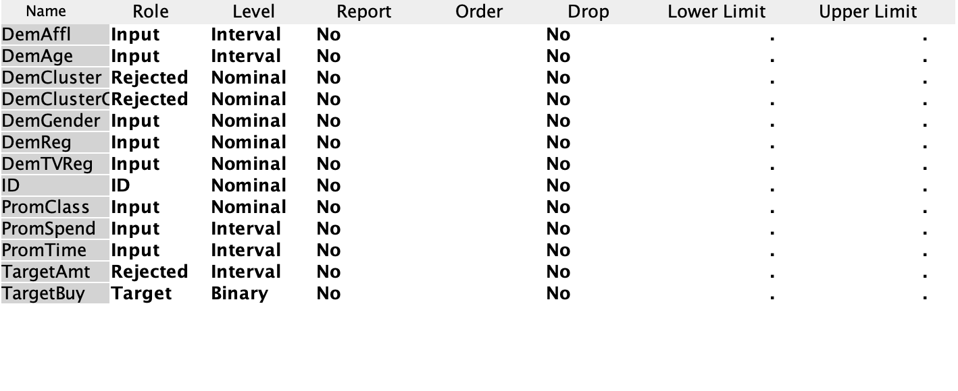
Decision Tree 1 Leaf Statistics
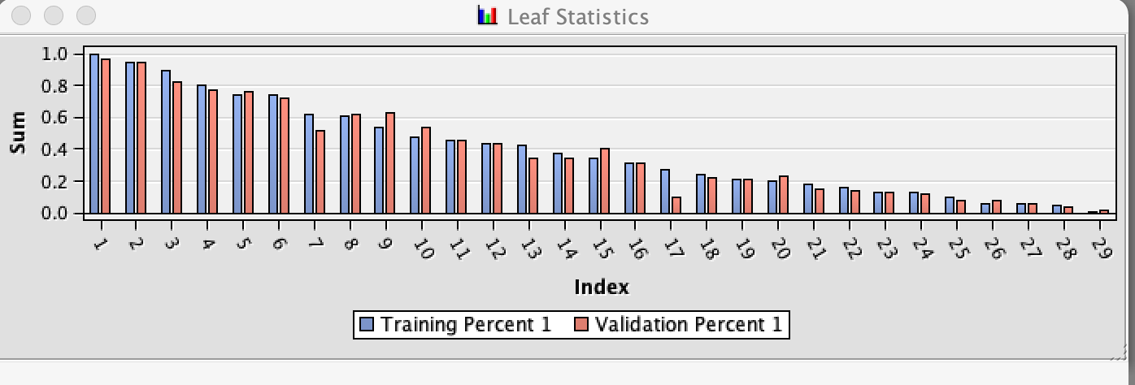Decision Tree 1
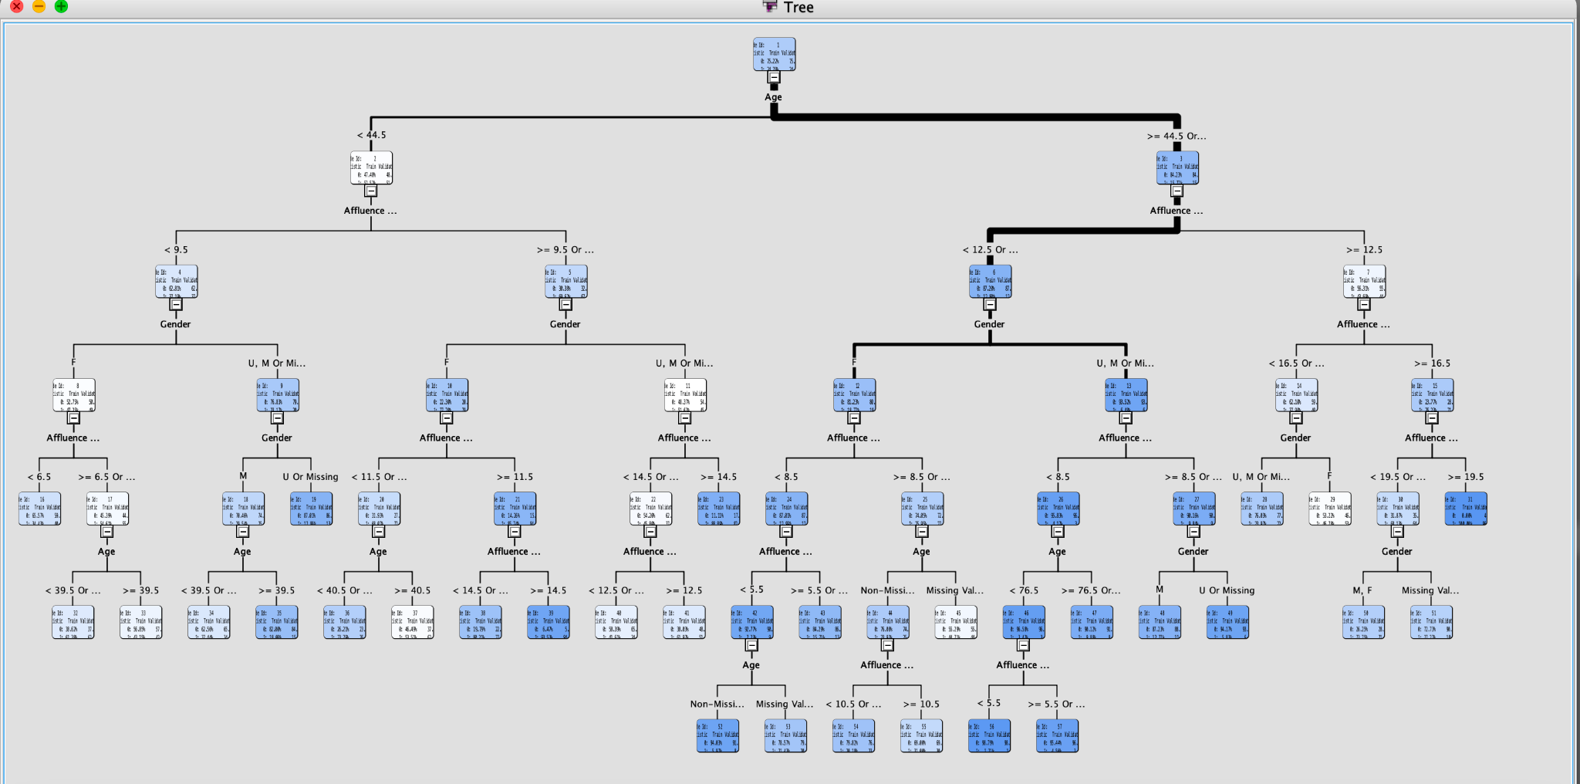
Variable Importance for Decision Tree 1
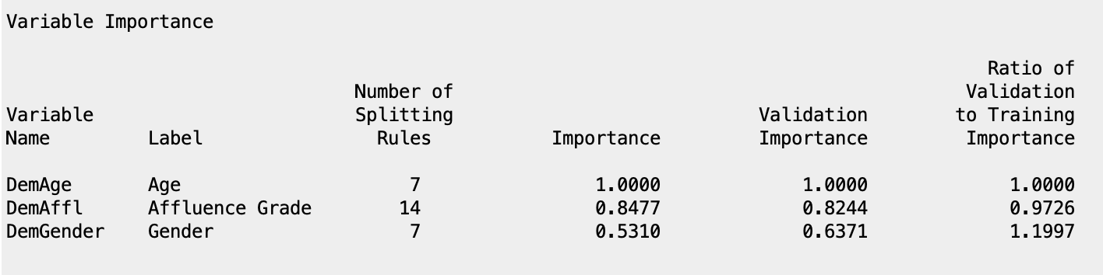
Decision Tree 1 Average Square Error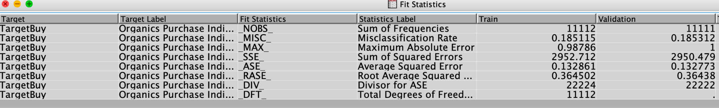
Decision Tree 2 Leaf Statistics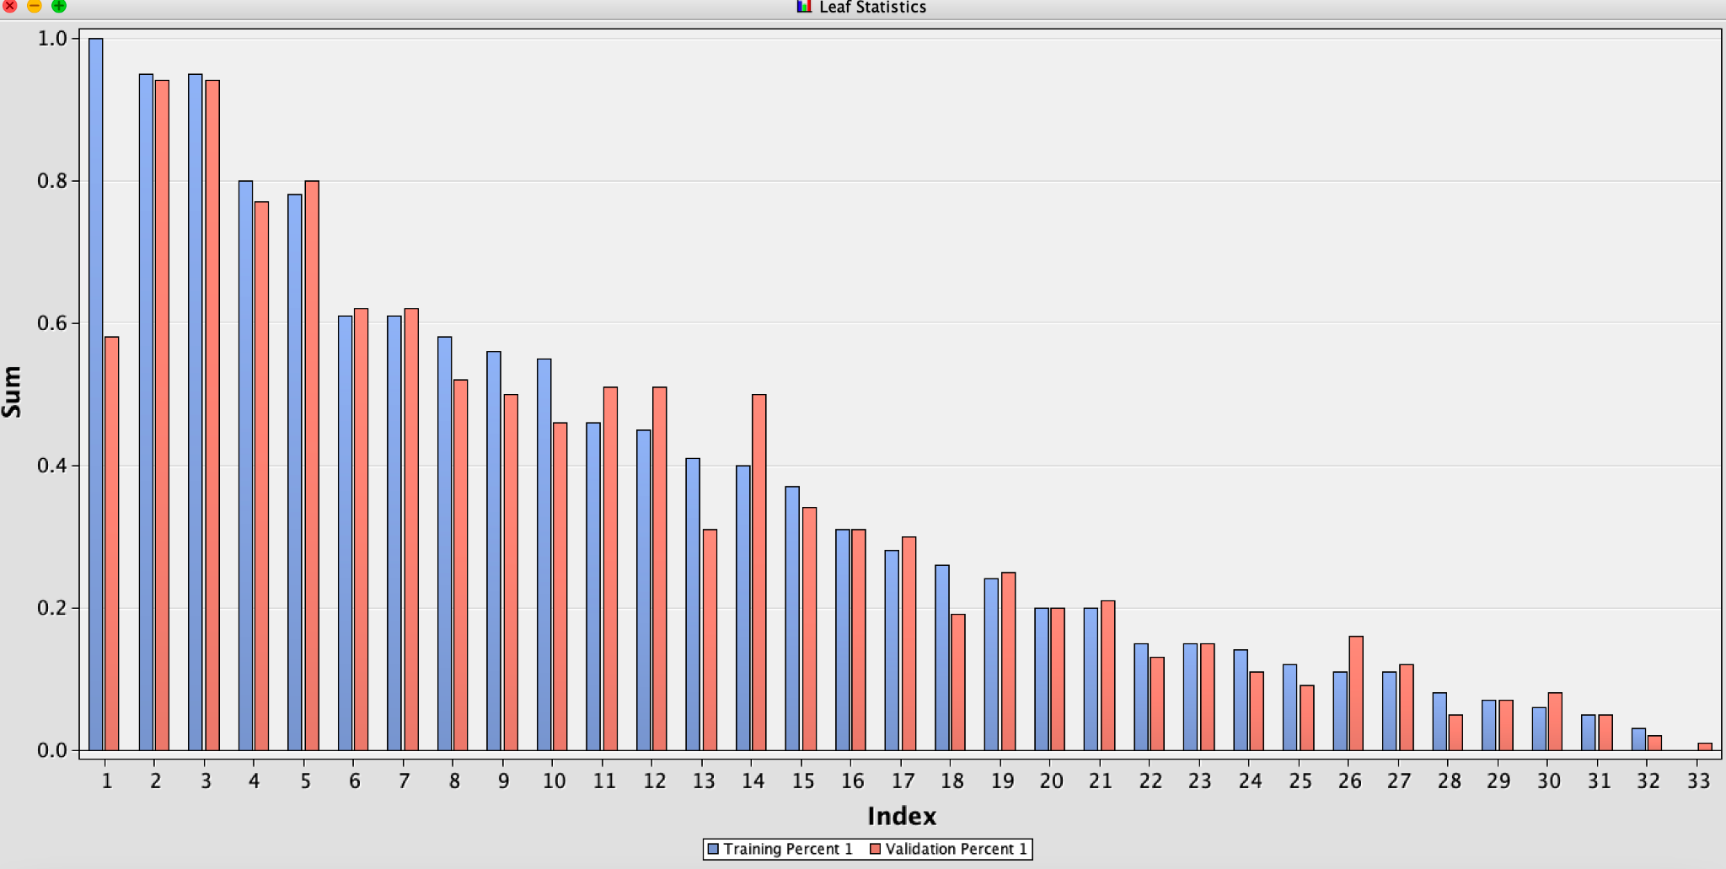
Decision Tree 2 (Does not fit all on one screen)
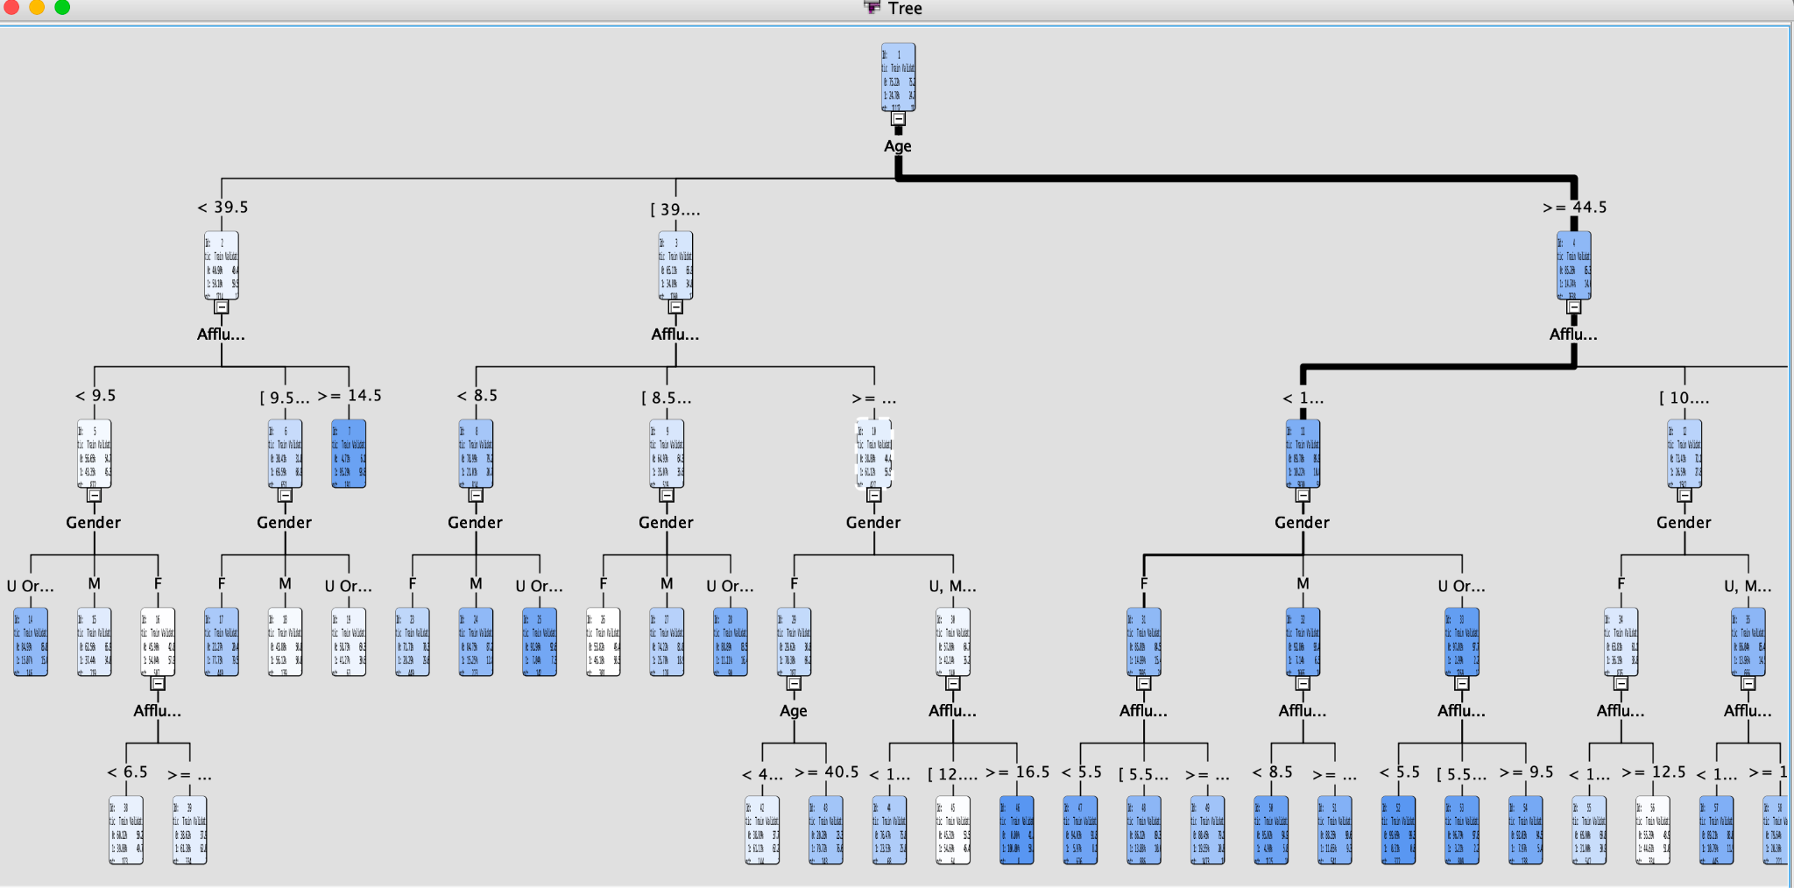
Variable Importance of Decision Tree 2
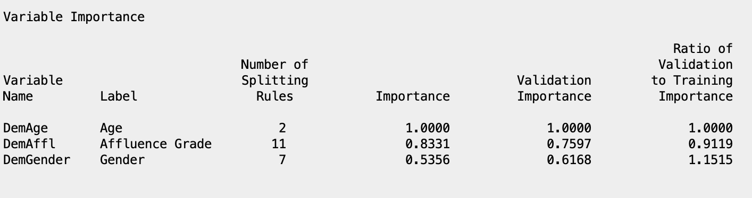
Decision Tree 2 Average Square Error
